McAfee GroupShield 6.0

Anti-Virus
- When a virus is found: Attempt to clean
- If cleaning succeeds: Log the item, Notify Administrator
- If cleaning fails: Replace the item with an alert message
- Custom malware actions: Delete the item, Log the item, Notify Administrators

Corrupt Content
- Replace the item with an alert message
- Quarantine the item, Log the item, Notify Administrators

Encrypted Content
- Replace the item with an alert message
- Quarantine the item, Log the item, Notify Administrators

File Filtering

- When no file filtering rule applies : Allow the item through
- IFAS Blocked Attachment Rule
  - Replace the item with an alert message
  - Quarantine the item, Log the item, Notify Administrators

Scanner Control
Denial of Service Protection
- Scan into maximum depth of nesting: 100
- Do not expand files larger than: 100 MB

Custom Malware Actions

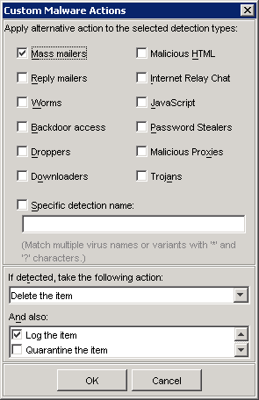
Exchange Global Address List (GAL) Naming Conventions

User
Last, First M.

Contact
Last, First M. – IFAS

Contact that reflects a ListSrv List:
. IFAS-XXX-L

Security Group
. IFAS-XXX

Distribution Group
. IFAS-XXX

Query-based Distribution Group
. IFAS-XXX

Note: Alias can be different

Address Lists for the Global Address List (GAL)

Lists will be generated on a query of Custom Attribute 15

Create Mailbox vs. Establish Email Address

Mailboxes are for people that want a mailbox and an IFAS email address

Established emails are for people that want an IFAS email address that gets forwarded to a non-IFAS email account

Note: Mailboxes can be forwarded to other GAL objects

Public Folders

Protocols

POP
Port 995 using SSL
Server email.ifas.ufl.edu
IMAP
Port 993 using SSL
Server email.ifas.ufl.edu

SMTP
Port 25 using SSL
Server email.ifas.ufl.edu

MAPI
Server exchange.ifas.ufl.edu

OWA
http://webmail.ifas.ufl.edu
https://email.ifas.ufl.edu/exchange
OMA
http://webmail.ifas.ufl.edu
https://email.ifas.ufl.edu/oma

RPC/HTTP

